Section slides: <http://webdev.slides.com/coltsteele/mysql-97-98#/43>

Inserting Data

* The INSERT INTO command is used to manually insert data into tables
  + When inserting data, one specifies the table name, the names of the columns that are being inserted into, and the values that are being inserted into those columns
  + The *order* of the column names and data inserted, as well as their datatypes, must match. You can declare and insert data in any order, as long as you are consistent between the names and data
  + In the example below, we insert into the *cats* table a cat named “Blue” whose age is 1. We’ll also add another cat named Draco, where we reverse the order in which we do the insertion





* Code for insertion of data:

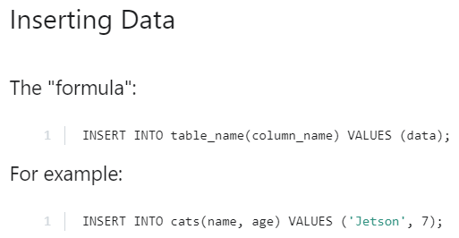

Selecting Data

* How do we know that our data insertion worked? In most cases, the best way is to use the **SELECT** command, which we’ll dive more into later in the course
* For now, to view the data in a given table, use **SELECT * from <table name>**



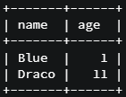

* Code review for data selection from a table



Multiple Inserts

* The INSERT command allows you to bulk insert data rather than just entering one at a time

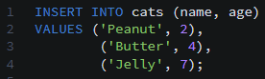

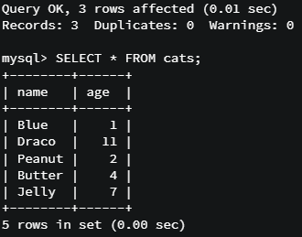

* Code summary for multiple inserts

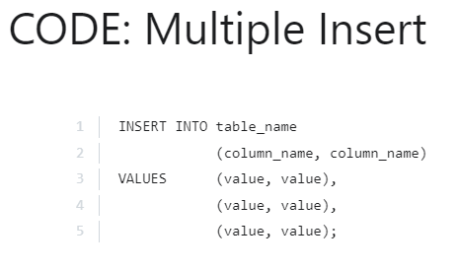

Inserting Literal Quotes into Values

* Normally, quotes are used to indicate that a value is to be a string. Sometimes however you want to have a literal single or double quote or quotes in your value. There are a couple ways to do this:

